Code documentation for The Lazy Bee project

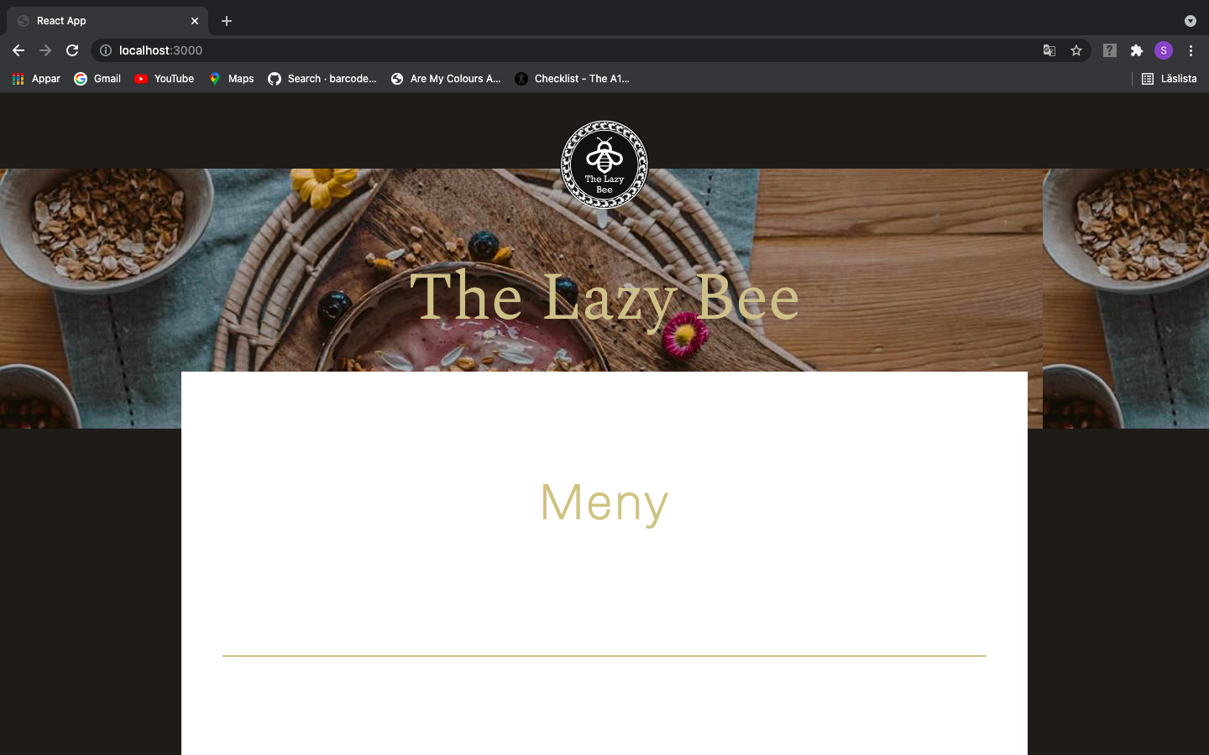

LANDINGPAGE

This is The Lazy Bee landing page where you will se The Lazy Bee logo that is spinning when touched and it is even link that leads to this main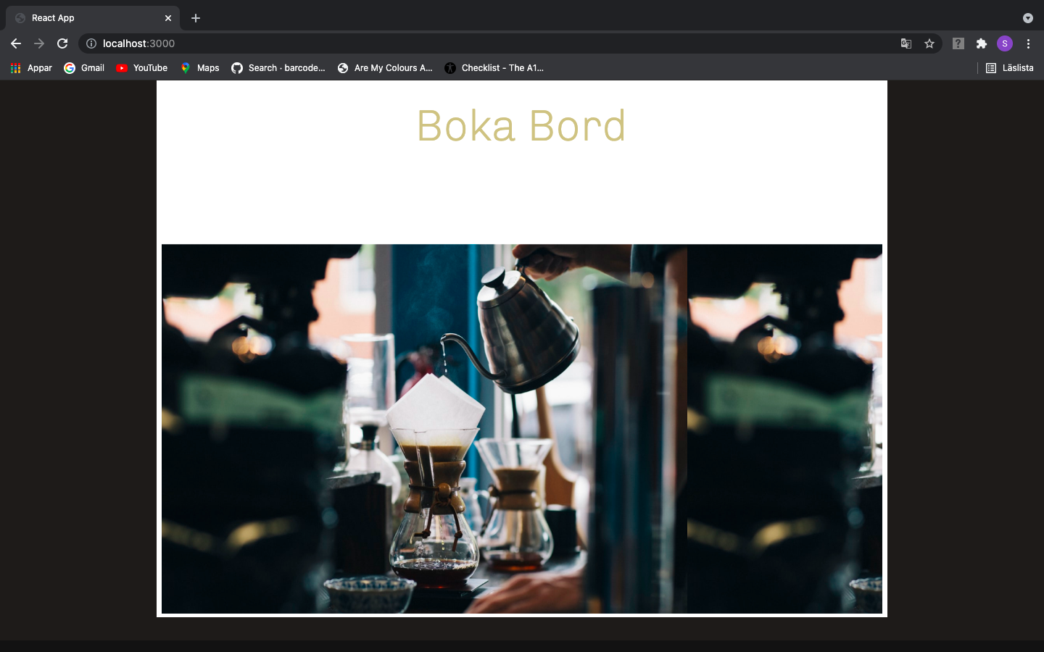 page from all the other pages in this application(see examples below). Meny and Boka Bord buttons are links that lead you to the Menu and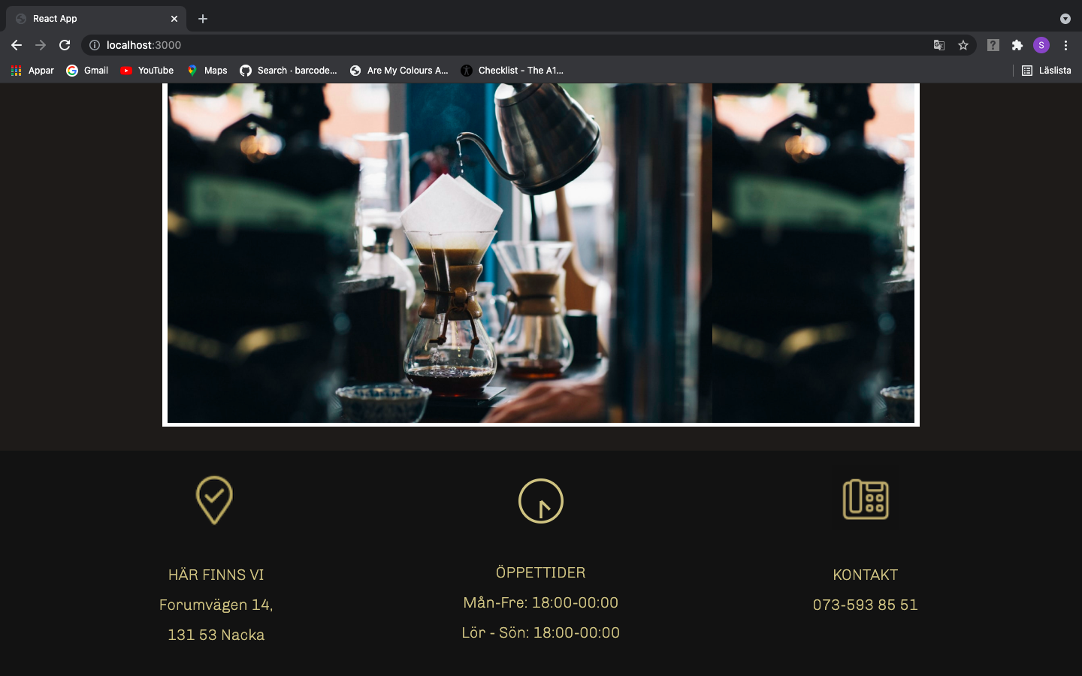 Table booking as they describe. You can also see the header that is same at all pages and dynamic so it just changes name of page you are looking at. Footer is at the end of page and shows information about the restaurant: where you can find it, its open hours and contact number.

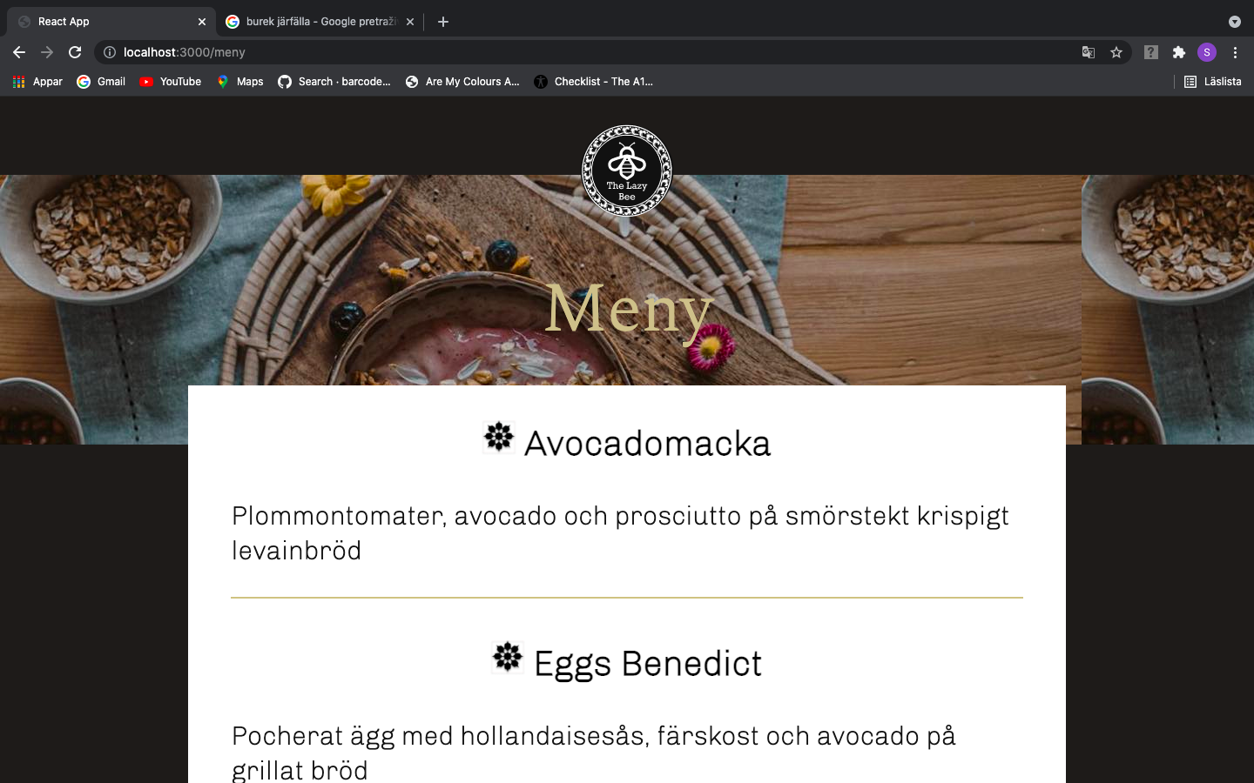

MENU PAGE

When you click on Meny button on start page you will come to a page where you can read the menu as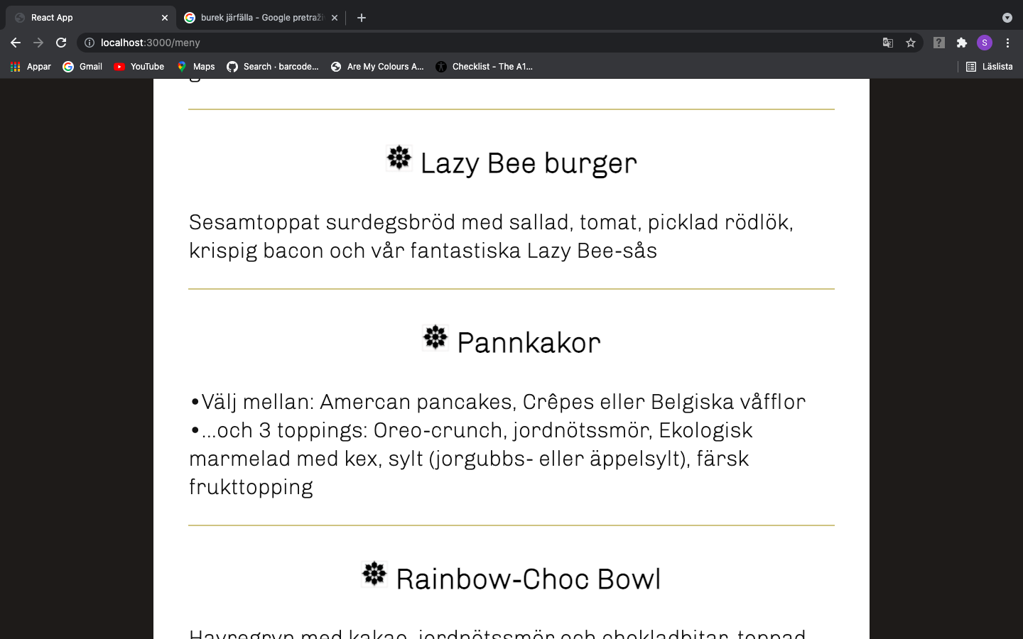 well as click on spinning button that will lead you to page for table booking.

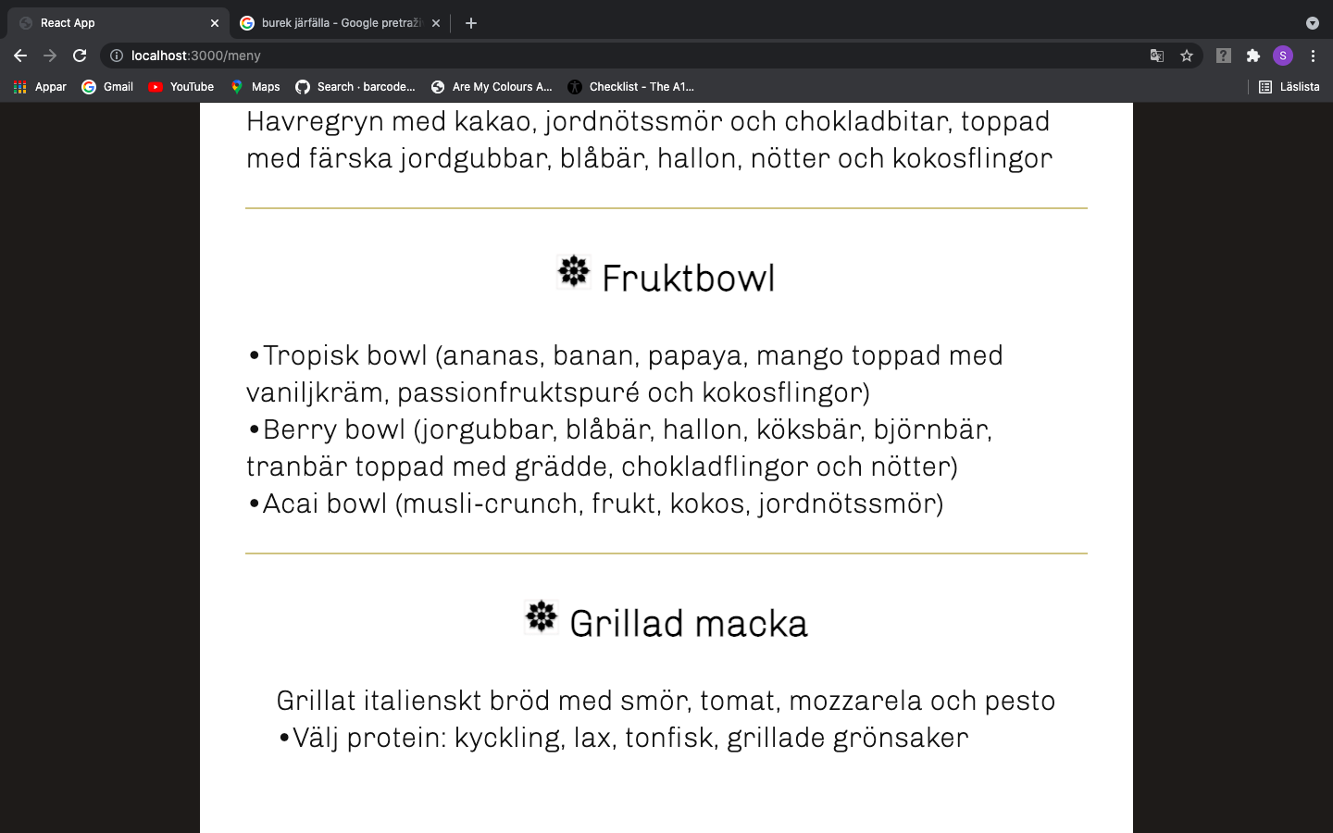

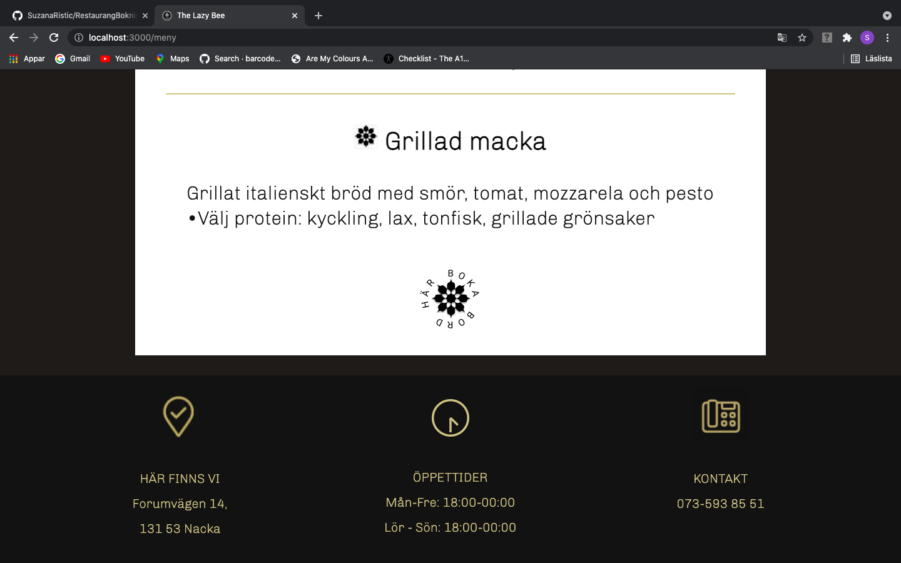

TABLE BOOKING PAGE

This is a table booking page. Button to go on to confirmation of booking table is disabled until guest doesn’t choose number of guests, date and time of arrival.

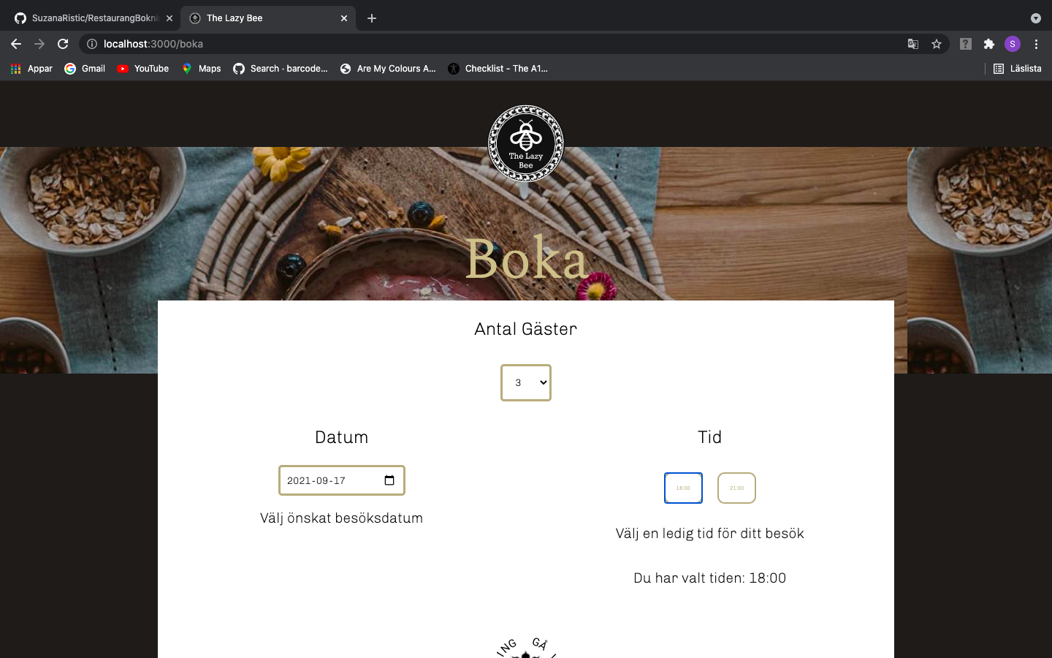

When guest chooses number of persons that are 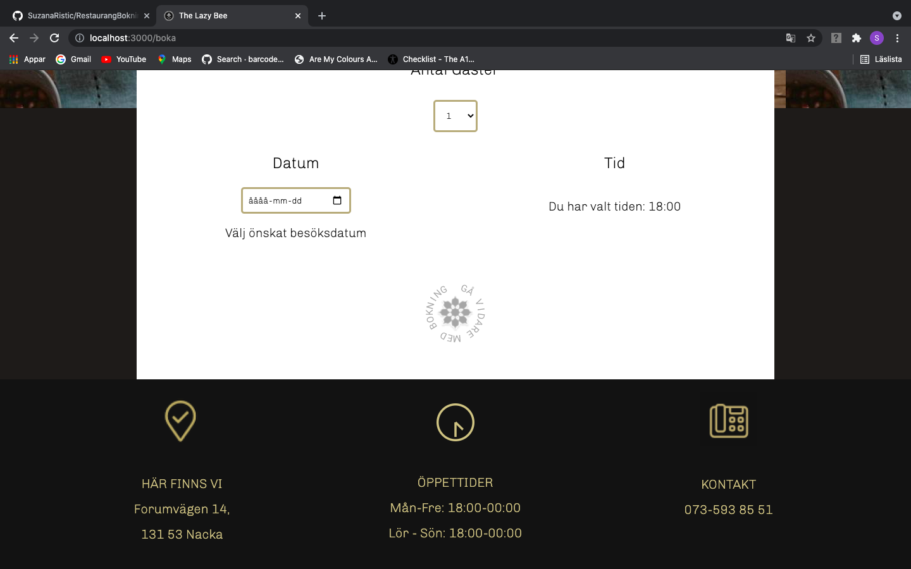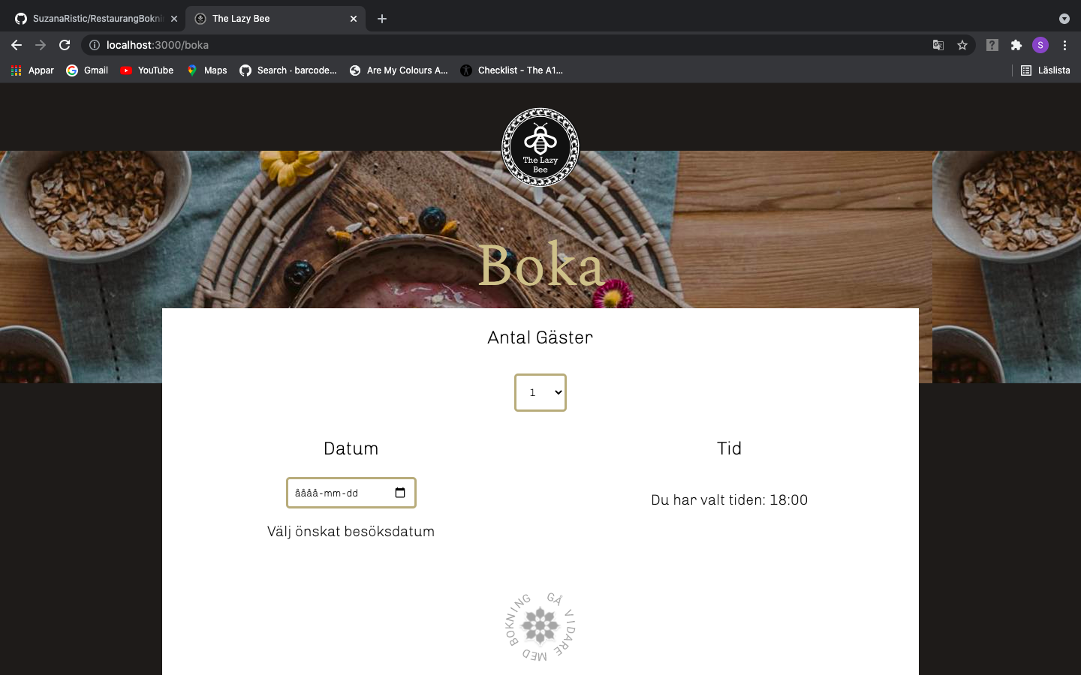visiting, date and time, button becomes darker and starts spinning when touched. In this moment guest can click the button that will lead him to page for confirmation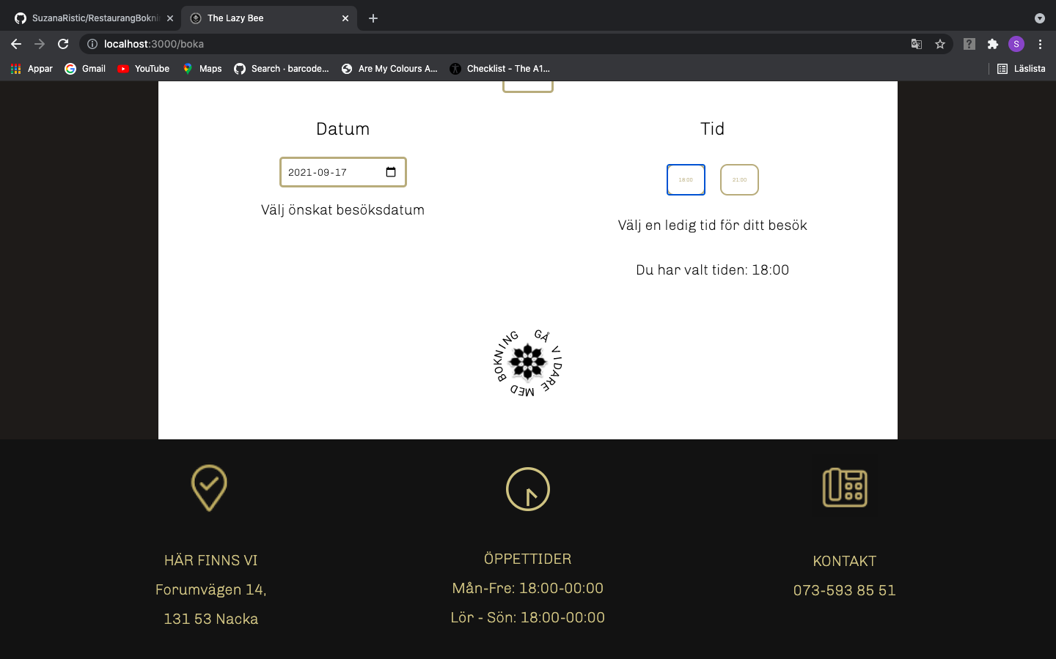 of booking where he can enter his personal information.

GUEST INFO BOOKING PAGE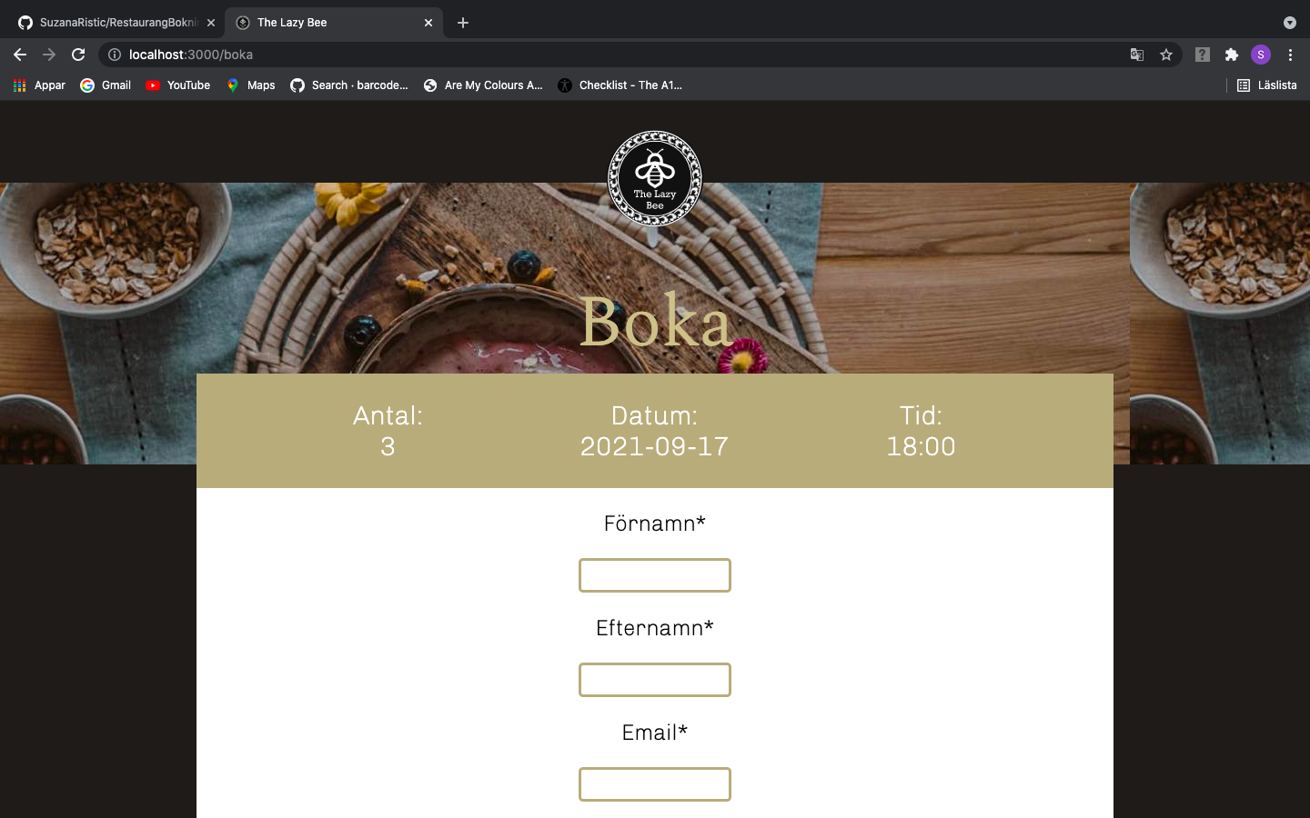

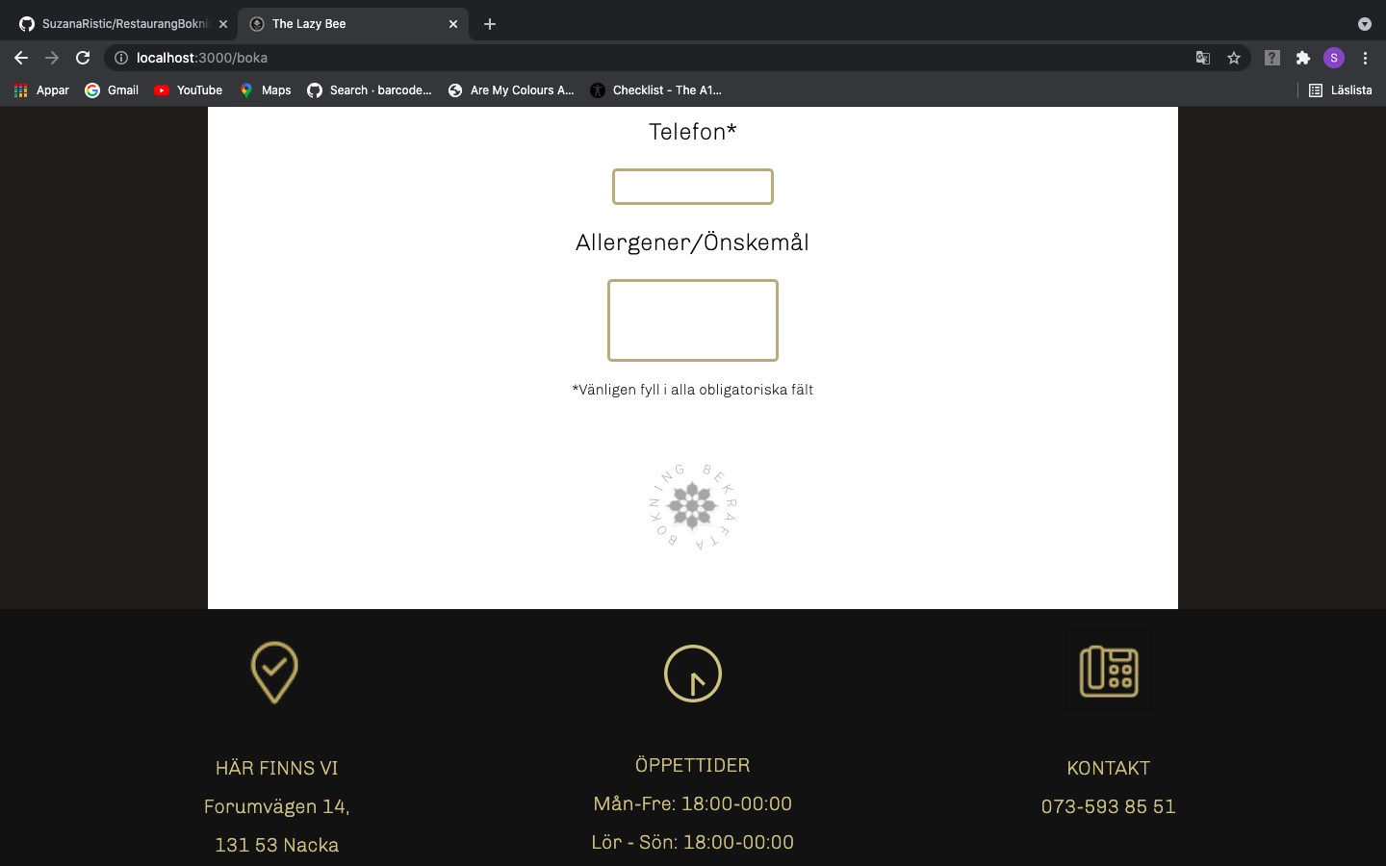

On this page guest can fill out the

form where he can write his name,

last name, email, phone number,

and any message or allergy notice

he has. Confirm booking button is

disabled until guest doesn’t fill in all

fields in valid form.

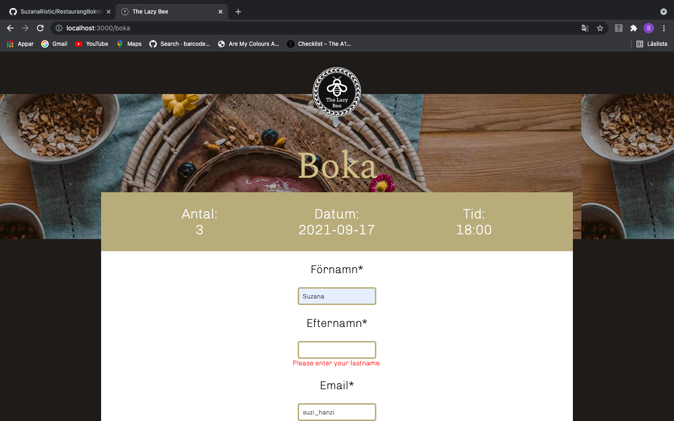

Validation can be seen if guest fills

invalid information to given fields.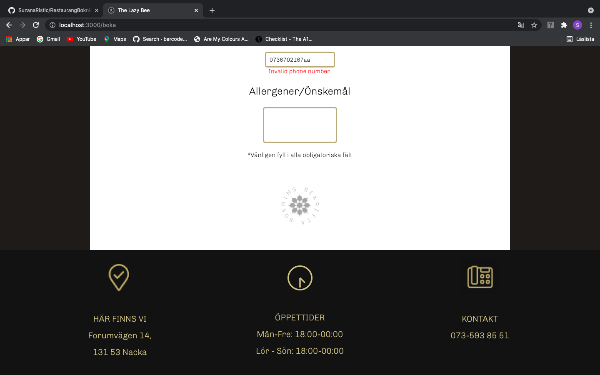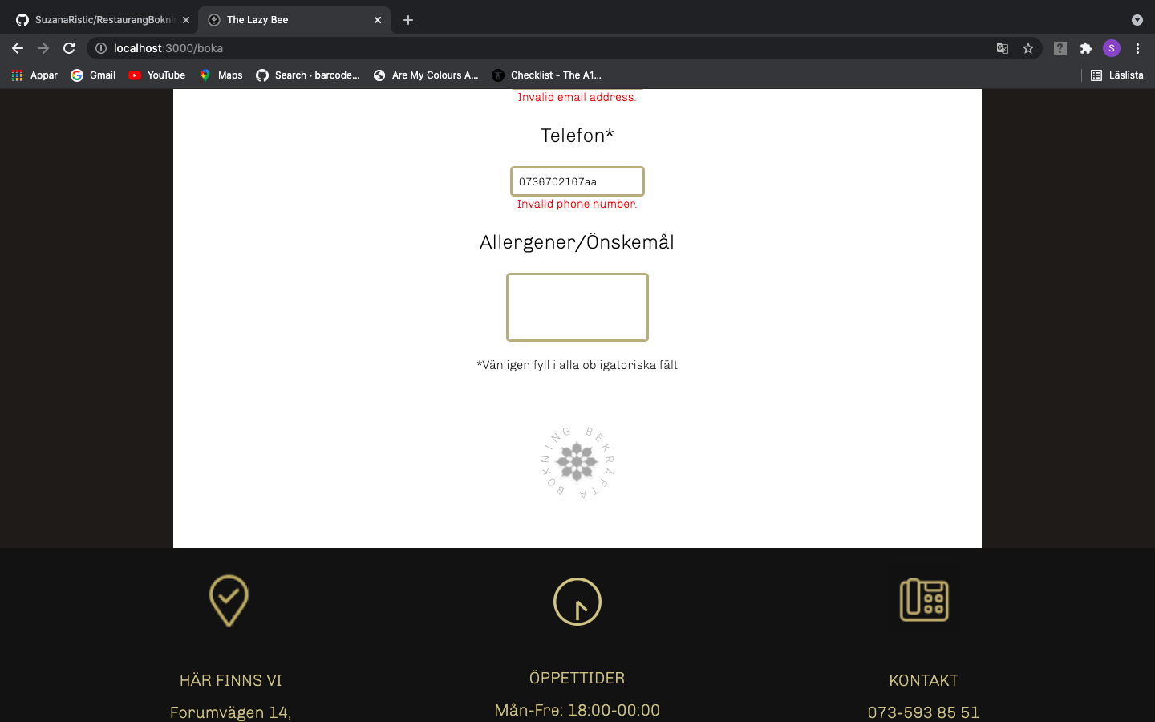

Button is still disabled until all

required field are filled correctly.

When all required fields are filled with needed information then button becomes black and starts spinning when touched which gives you opportunity to confirm booking. When this button is pressed booking is saved into database and can be seen by admin.

CONFIRMATION PAGE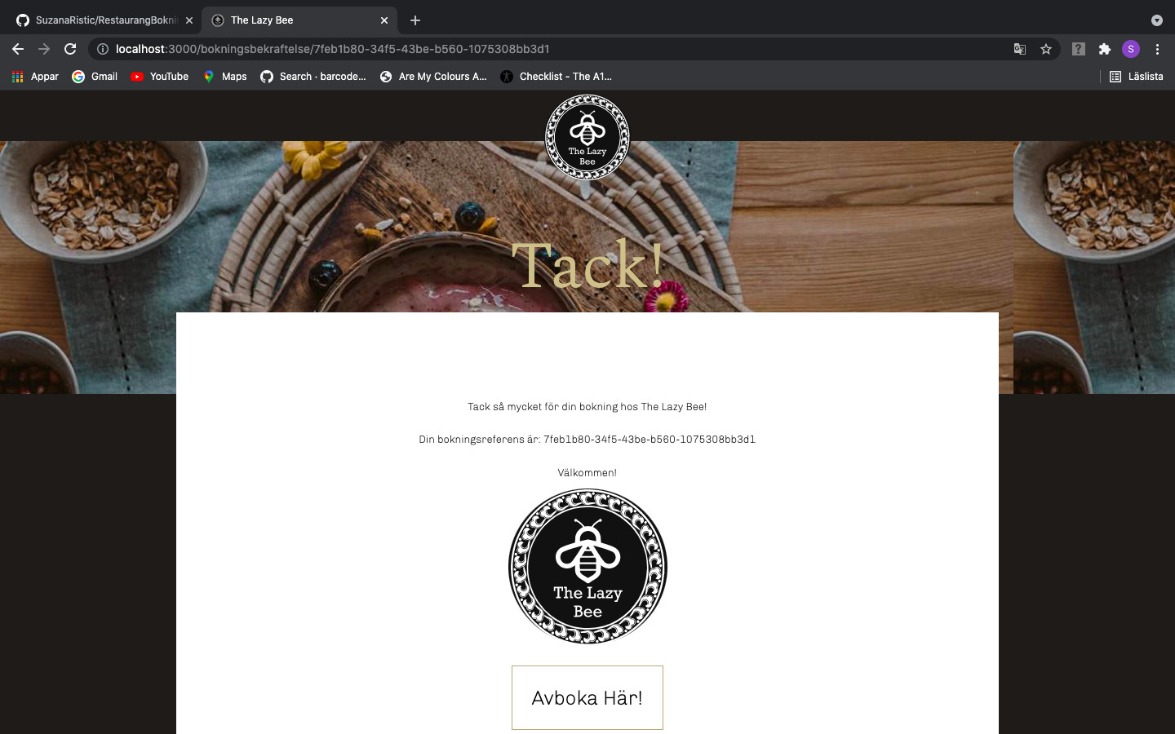

This is a confirmation page whe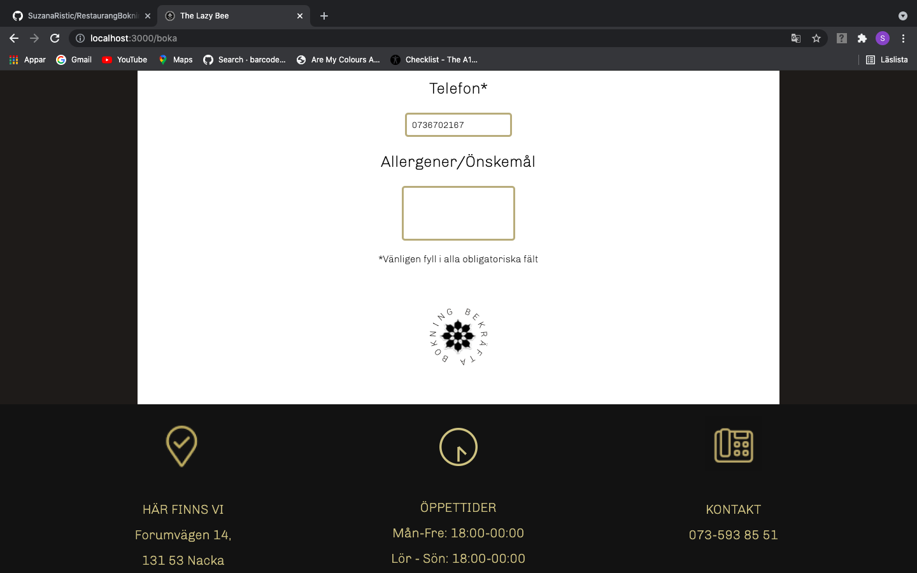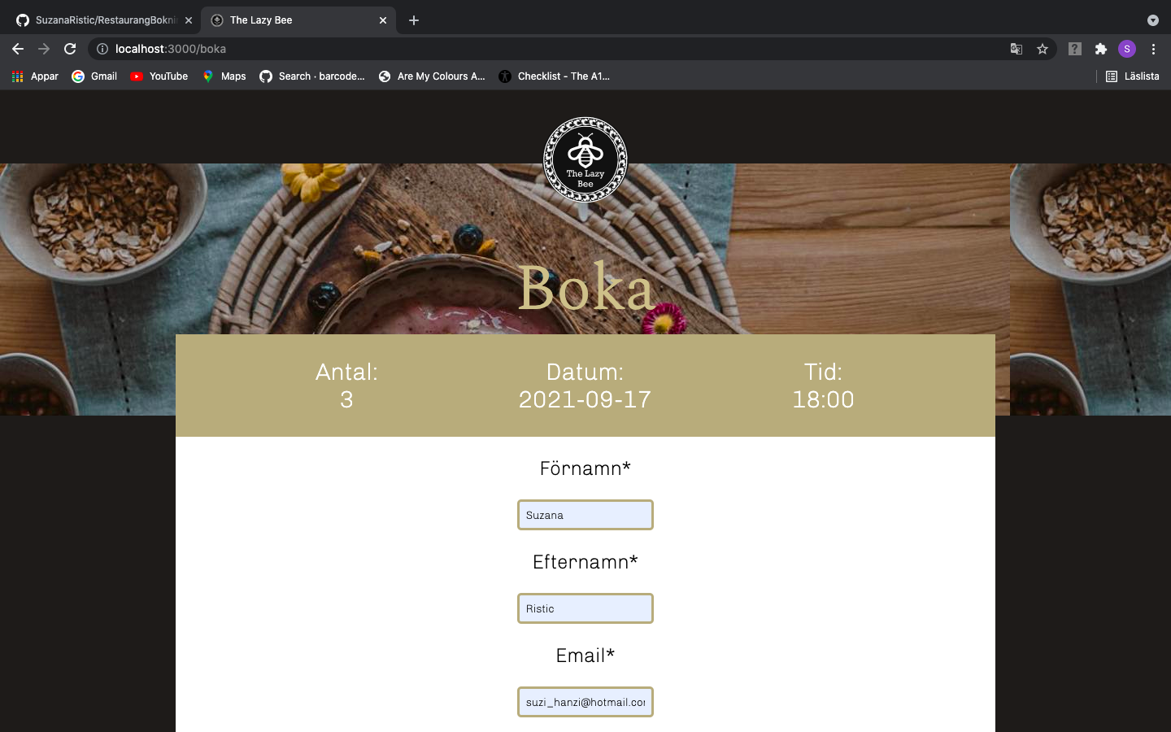re guest can see confirmation for his booking which he gets at his mail as well(see picture below). Guest can both cancel booking by pressing ”Avboka här” button as well as following link that he got at his email. Both ”Avboka här” but ton and link will lead him to

page where he confirms cancelation of booking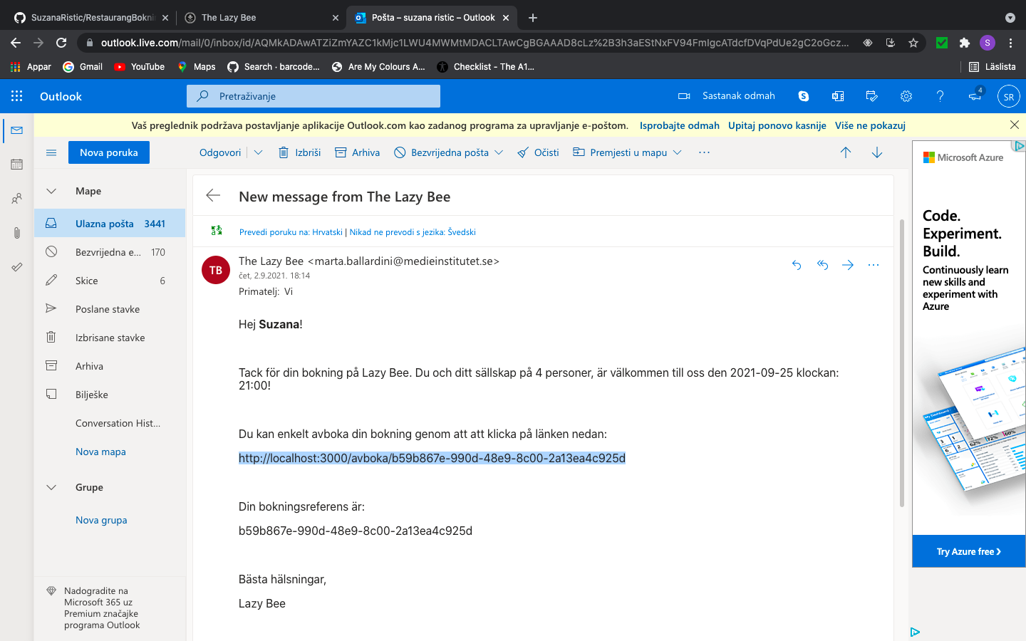

CONFIRM CANCELATION PAGE

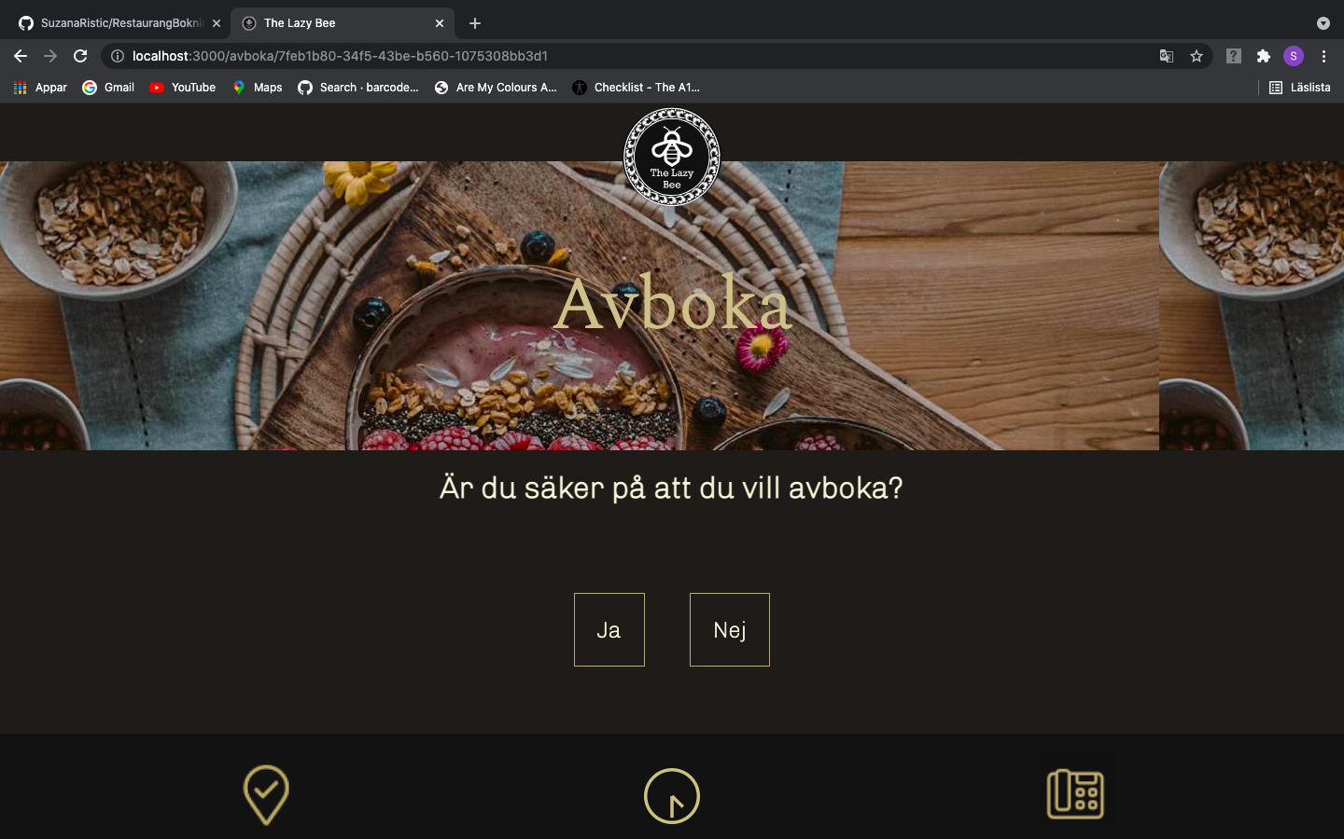

At this point guest can choose if he wants to cancel booking. If pressed no (nej) he will be led to start page, and if pressed yes he will get email that confirms cancelation as well as message for that on the screen. See pictures bellow.

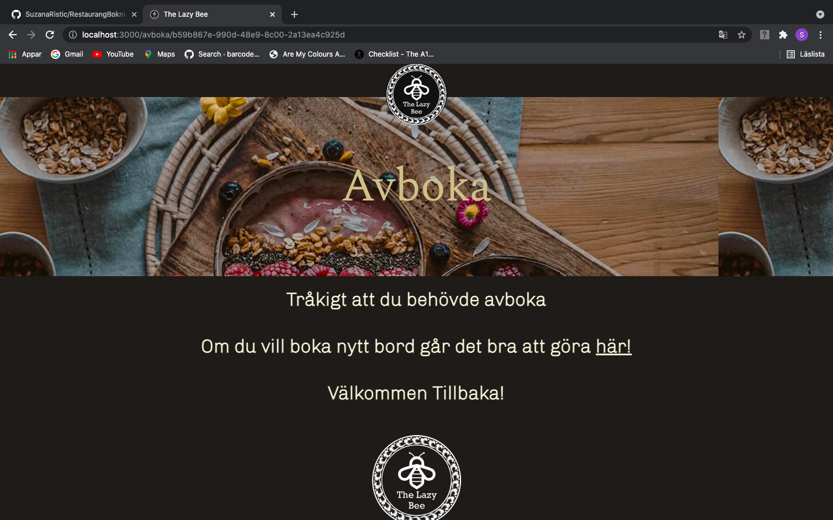

If pressed here(här) link guest will be led to table booking page.

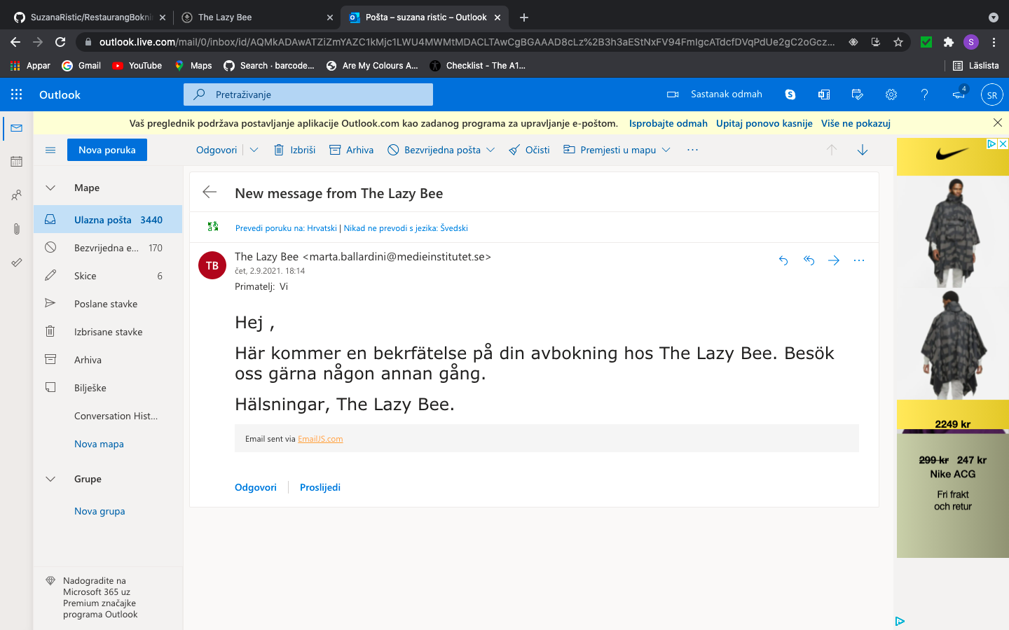

Email that confirms cancelation